|  |  |  |  |
| --- | --- | --- | --- |
| **paf_kiet_logo** | **COLLEGE OF COMPUTING AND INFORMATION SCIENCES** | | |
| **Final Assessment of Lab Exam (Fall 2021 Semester)** | | |
| **Class Id** | 106278 | **Course Title** | Object Oriented Programming |
| **Program** | BSCS | **Campus / Shift** | Main/ Morning |
| **Date** | April 20, 2021 | **Total Marks** | 20 |
| **Duration** | 02 hours 30min | **Faculty Name** | Umna Iftikhar |
| **Student Id** | 12113 | **Student Name** | Shahmeer khan. |
| **Code** | **A** |  |  |

**Instructions:**

* Fill out your Student ID and Student Name in above header.
* Do not remove or change any part question paper.
* Write down your answers with title “Answer for Question# 00”.
* Handwritten text or image should be on A4 size page with clear visibility of contents.
* In case of CHEATING, COPIED material or any unfair means would result in negative marking or ZERO.
* Viva can be taken with prior notice, where deemed necessary.
* **Caution:** Duration to perform Final Assessment is **02 hours only and 30 MIN** is given to cater all kinds of odds in submission of Answer-sheet. **Therefore, if you failed to upload answer sheet on LMS (in PDF format) within 2:30 hours’ limit, you would be considered as ABSENT/FAILED.**

**[5 mark]**

1. ***Students having even roll no's have to solve scenario (a) and for odd roll no's scenario (b)***
2. You are given the definition of a base class named as Polygon. A polygon is a closed figure with three or more sides. Class Polygon is an Abstract Base Class since it contains two abstract methods. You are going to implement the child classes which are class Square and Triangle.
3. Square class is the subclass/child class of superclass Polygon, since Square is a polygon with 4 sides, where each side is equal.
4. Triangle class is the subclass/child class of superclass Polygon, since triangle is a polygon with 3 sides.
5. Both these subclasses have same named method; hence they are polymorphic.

1. Given the following scenario:

Blood pressure reading basically has two numbers, for example 125/85 mmHg. The top number (125) is called systolic while the bottom number (85) is called diastolic. Based on these readings, level of blood pressure of a person can be determined, such as low, ideal, pre-high or high blood pressure. Identify three (3) attributes and three (3) behaviors that could be used for that scenario. Then, write a complete program that can read blood pressure for systolic and diastolic until the user request to stop(sentinel-controlled loop) and do the following:

1. Find maximum readings of diastolic and minimum reading of systolic.
2. Calculate average readings of diastolic and systolic.
3. Count the number of persons that can be categorized as low blood pressure where the reading of systolic is less than 90 and diastolic is less than 60.
4. Count the number of persons that can be categorized as high blood pressure where the reading of systolic is greater than 140 and diastolic is greater than 90.
5. Display all the results obtained in appropriate output format (based on your creativity)

**[Add screen shot of code & output here]**

**[10 mark]**

1. ***Students having even roll no's have to solve scenario (a) and for odd roll no's scenario (b)***
2. Perform overridingin the following class diagram.

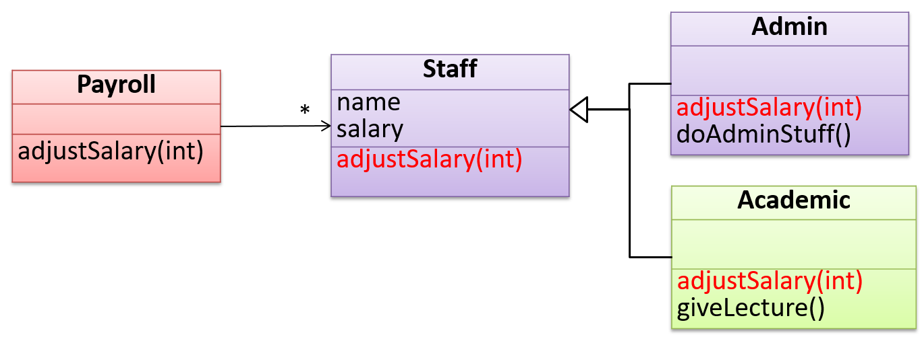

1. Write a program that uses an array to find the Average of a set float value entered by the user. You will have the main function control the operation of the program, but all values will be stored in the class.

You will need to use get and set methods in your class.

1. Create an array as a member of the class.
2. Create 1 method to handle user input.
3. Create 1 method to sum all numbers in array.
4. Create 1 method to output the average of all numbers input bythe user,
5. Create 1 method to output all the numbers input by the user.

**[Add screen shot of code & output here]**

**Question no. 2 Part b:**

**Inputted Code:**

using System;

using System.Collections.Generic;

using System.Linq;

using System.Text;

using System.Threading.Tasks;

namespace \_12113\_Shahmeer\_s\_OOP\_LAB\_S\_PAPER

{

class Program

{

static void Main(string[] args)

{

Console.WriteLine("OOP LAB PAPER:");

Console.WriteLine("Question no. 2:");

Array arr = new Array();

arr.array = new double[10];

arr.UserInput();

arr.arraysum();

arr.averageofarray();

arr.arrayelements();

Console.ReadKey();

}

}

class Array

{

public double[] array;

public void UserInput()

{

Console.WriteLine("\nDefine the array: ");

for (int i = 0; i < array.Length; i++)

{

array[i] = double.Parse(Console.ReadLine());

}

}

public void arraysum()

{

double a = 0;

Console.WriteLine("\nSum of all numbers in Array is: ");

for(int j=0; j<array.Length;j++)

{

a += array[j];

}

Console.WriteLine(a);

}

public void averageofarray()

{

double b = array.Length;

double a = 0;

for (int j = 0; j < array.Length; j++)

{

a += array[j];

}

double average = a / b;

Console.WriteLine("\nThe average of all numbers input by the user: " + average);

}

public void arrayelements()

{

Console.WriteLine("\nThe numbers inputted by the user:");

for(int i = 0; i < array.Length; i++)

{

Console.WriteLine(array[i]);

}

}

}

}

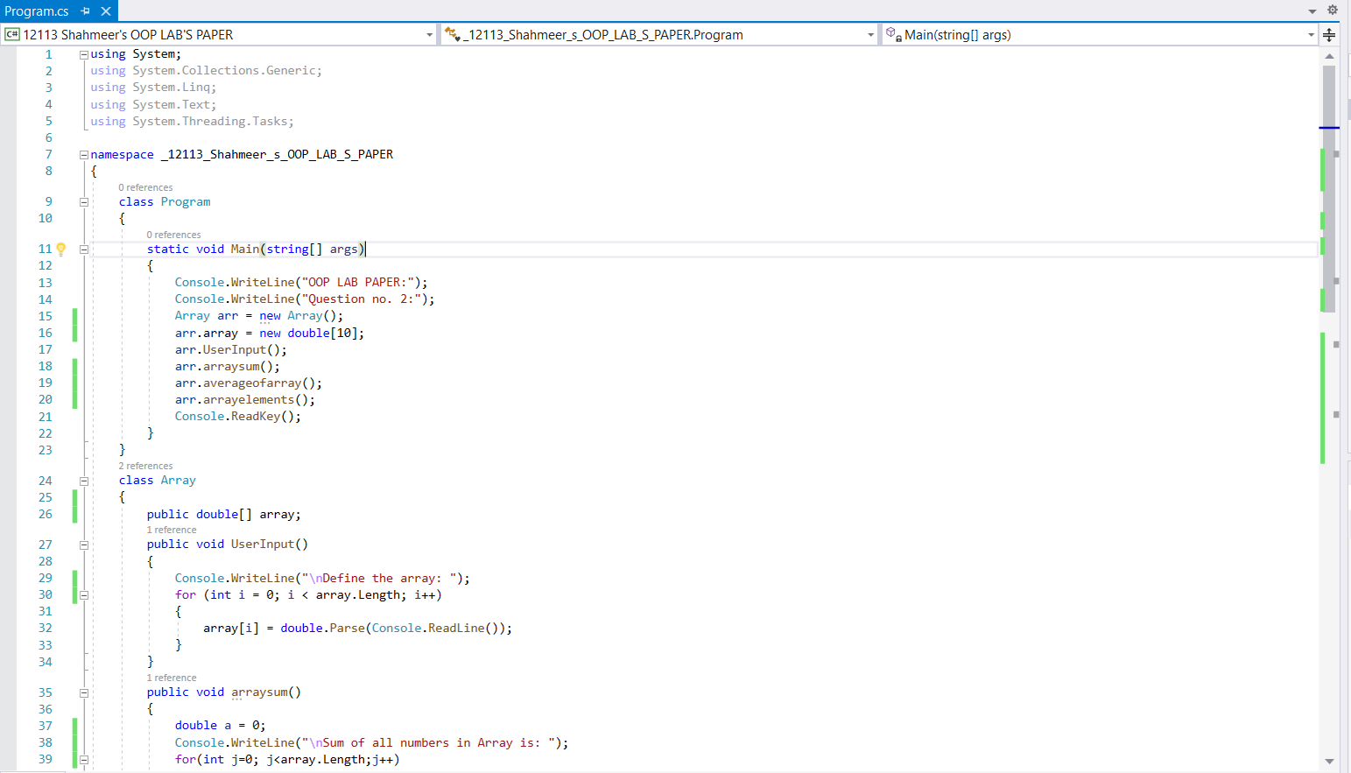

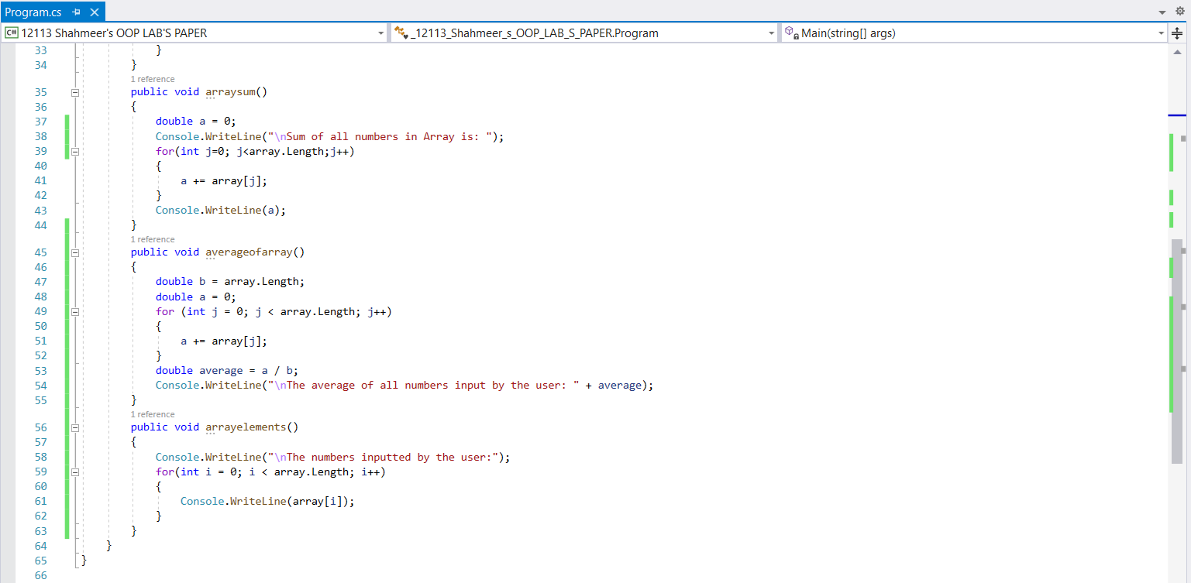

**Output:**

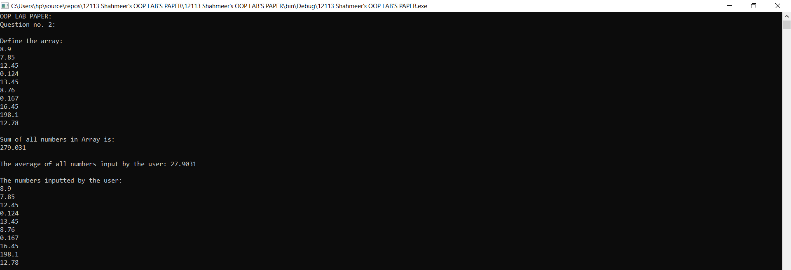

**[5 mark]**

1. ***Students having even roll no's have to solve scenario (a) and for odd roll no's scenario (b)***
2. Prepare the following classes in C#

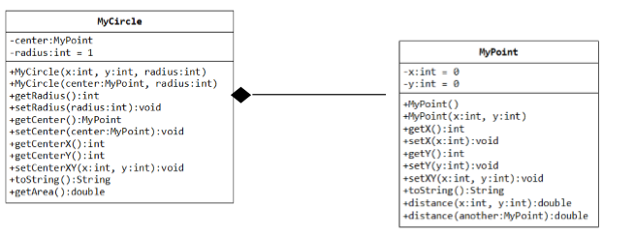

1. Prepare the following classes in C#

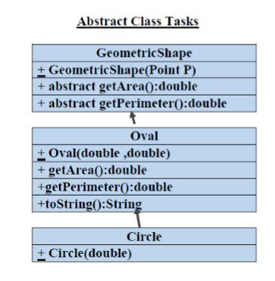

**[Add screen shot of code & output here]**

**Question no. 2 Part b:**

**Inputted Code:**

using System;

using System.Collections.Generic;

using System.Linq;

using System.Text;

using System.Threading.Tasks;

namespace \_12113\_Shahmeer\_s\_OOP\_LAB\_S\_PAPER

{

class Program

{

static void Main(string[] args)

{

Console.WriteLine("OOP LAB PAPER:");

Console.WriteLine("Question no. 3:");

overrider OV = new overrider();

OV.Printer();

Console.ReadKey();

}

}

abstract class GeometricShape

{

protected abstract void geometricshape(int Point\_P);

public abstract double GetArea();

public abstract double getPerimeter();

}

abstract class Oval : GeometricShape

{

protected abstract void oval(double a, double b);

public abstract double getArea();

public abstract double GetPerimeter();

public abstract string toString();

}

abstract class Circle : Oval

{

protected abstract void circle(double c);

}

class overrider : Circle

{

//GeometricShape Methods

protected override void geometricshape(int Point\_P)

{

Point\_P = 4;

Console.WriteLine("Geometric shape has no. of points " + Point\_P);

}

public override double GetArea()

{

int a = 0;

return a;

}

public override double getPerimeter()

{

int b = 4;

return b;

}

//Oval Methods

protected override void oval(double a, double b)

{

Console.WriteLine("Oval Method has 2 parameters");

}

public override double getArea()

{

int a = 0;

return a;

}

public override double GetPerimeter()

{

int b = 1;

return b;

}

public override string toString()

{

return "\nThe Area of GeometricShape is " + GetArea() + " And it's parameters are " + getPerimeter() +

"\nThe Area of Oval is " + getArea() + " And it's perimeters are " + GetPerimeter();

}

public void Printer()

{

Console.WriteLine(toString());

}

//circle's methods

protected override void circle(double c)

{

Console.WriteLine("Number of Circles are " + c);

}

}

}

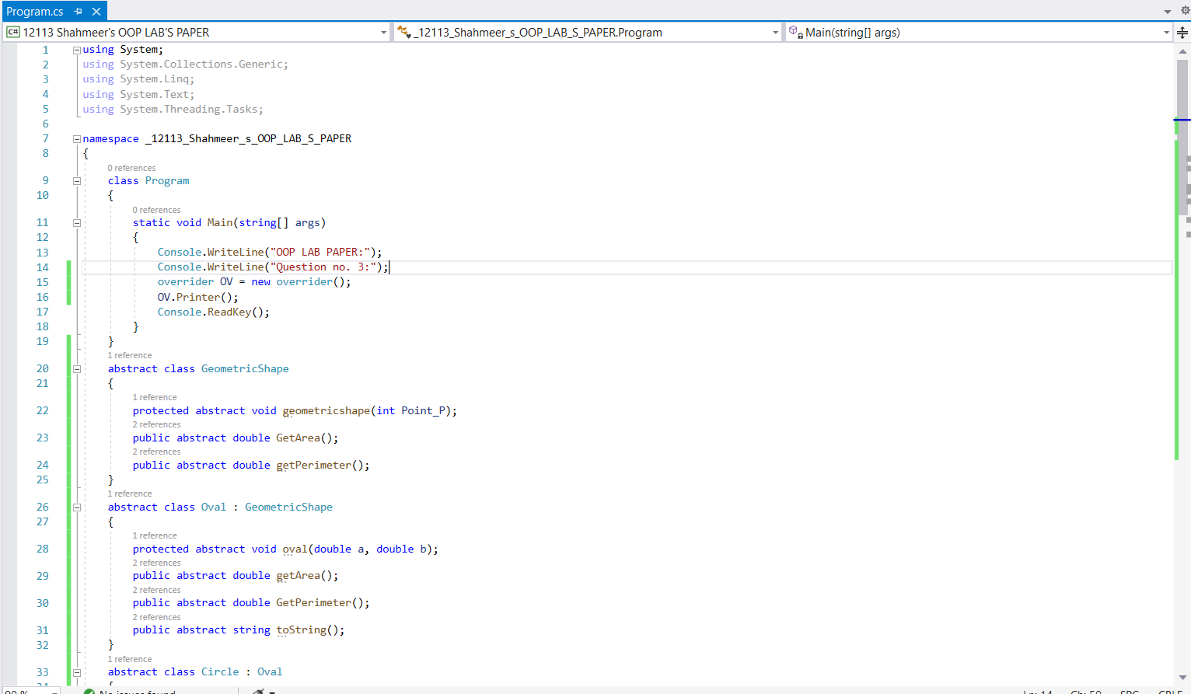

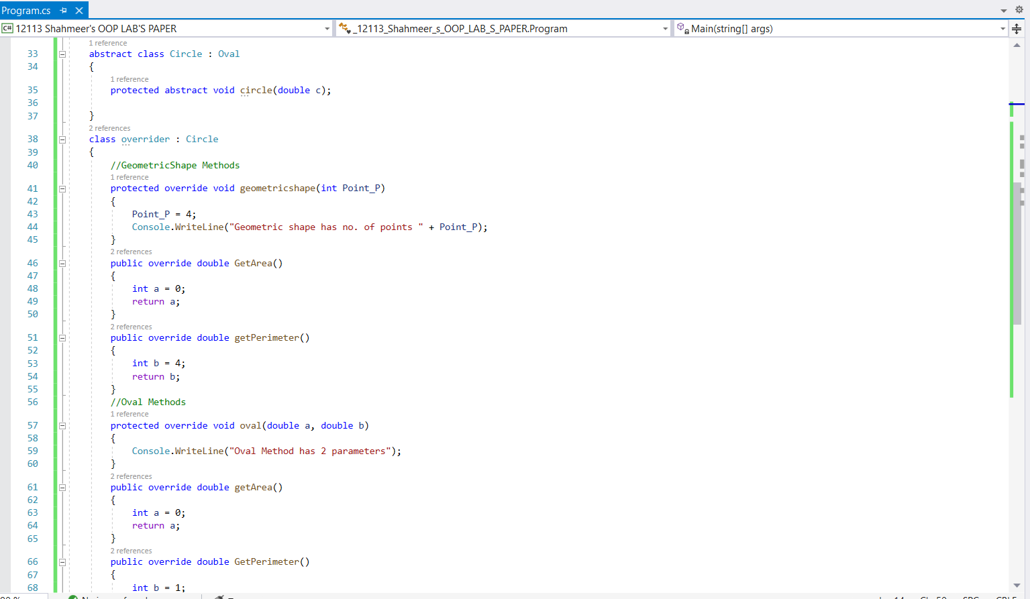

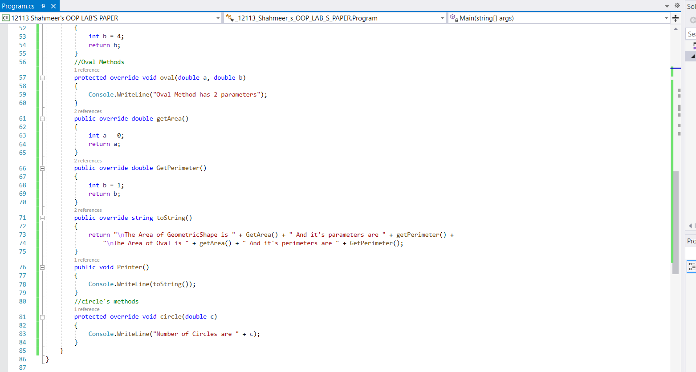

**Output on next page**

**Output:**

